**THE STATE EDUCATION DEPARTMENT / THE UNIVERSITY OF THE STATE OF NEW YORK / ALBANY, NY 12234**

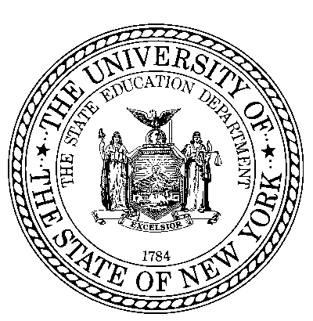

Office of P-20 Education Policy

Child Nutrition Program Administration

89 Washington Avenue, Room 375 EBA, Albany, NY 12234

(518) 473-8781 Fax (518) 473-0018

[www.nysed.gov/cn/cnms.htm](http://www.nysed.gov/cn/cnms.htm)

Whitehall CSD - Letter to Parents for School Meal Programs

Special Provision Options (Provision 2 Non-Base Year & Community Eligibility Provision)

Dear Parent or Guardian:

We are pleased to inform you that Whitehall Central School District will be implementing a meal certification option available to schools participating in the National School Lunch and School Breakfast Programs for the 2024-2025 school year.

**What does this mean for your child(ren) attending the school(s) identified above?**

All students enrolled at Whitehall Central School District are eligible to receive a healthy breakfast and lunch at school at **no charge** to your household each day of the 2024-25 school year. No further action is required of you. Your child(ren) will be able to participate in these meal programs without having to pay a fee or submit an application.

If you have any further questions, please contact Susan Frank, (518) 464-5133, [susan.frank@neric.org](mailto:susan.frank@neric.org).

Sincerely,

Ryan Withrow, Food Service Director

In accordance with federal civil rights law and U.S. Department of Agriculture (USDA) civil rights regulations and policies, this institution is prohibited from discriminating on the basis of race, color, national origin, sex (including gender identity and sexual orientation), disability, age, or reprisal or retaliation for prior civil rights activity.

Program information may be made available in languages other than English. Persons with disabilities who require alternative means of communication to obtain program information (e.g., Braille, large print, audiotape, American Sign Language), should contact the responsible state or local agency that administers the program or USDA’s TARGET Center at (202) 720-2600 (voice and TTY) or contact USDA through the Federal Relay Service at (800) 877-8339.

To file a program discrimination complaint, a Complainant should complete a Form AD-3027, USDA Program Discrimination Complaint Form which can be obtained online at: https://www.usda.gov/sites/default/files/documents/USDA-OASCR%20P-Complaint-Form-0508-0002-508-11-28-17Fax2Mail.pdf, from any USDA office, by calling (866) 632-9992, or by writing a letter addressed to USDA. The letter must contain the complainant’s name, address, telephone number, and a written description of the alleged discriminatory action in sufficient detail to inform the Assistant Secretary for Civil Rights (ASCR) about the nature and date of an alleged civil rights violation. The completed AD-3027 form or letter must be submitted to USDA by:

1. mail: U.S. Department of Agriculture

Office of the Assistant Secretary for Civil Rights

1400 Independence Avenue, SW

Washington, D.C. 20250-9410; or

1. fax: (833) 256-1665 or (202) 690-7442; or
2. email: [program.intake@usda.gov](mailto:program.intake@usda.gov).

This institution is an equal opportunity provider.